Kentucky Wonder Pole Beans
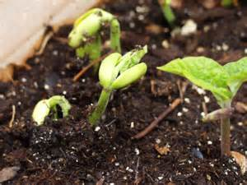
Pole-style green beans are a space-saver in a garden. Because they grow upward, they take one-half the space it takes to grow bush beans, and they produce more beans than bush beans over a longer season. "Kentucky Wonder" is an heirloom pole bean variety that produces 8-inch long pods on 6- to 8-foot long vines. It is resistant to bean rust, which can lead to reddish-orange spots and pustules on leaves and pods, and its beans are ready to be picked starting 65 days after sowing and planting them, about 10 days earlier than many pole bean varieties.
- We’ve already planted your seeds inside peat pellets. Keep the peat pellet in their plastic bowls with lids covering them in the dark and check the pellets daily to ensure they are moist but not overly wet until the bean plant sprouts (7 to 14 days) until they sprout. Then remove the plastic top and move the bowl with the plants and pellets to a sunny window.
- When the bean sprouts are about 3 inches in height, place the bowl out in the shade for a couple days, moving them inside in the evenings, then plant the whole pellet in a sunny location in the garden about 1-1 1/2 feet apart. Be sure to till the soil well where you will plant them as beans roots can get to 30” in length. Provide them with a trellis or trio of bamboo poles so their vines are able to grow upward.
- Water the soil deeply around them once a week as needed – remembering to avoid water on their foliage. As the plants begin to grow taller, provide them with at water but avoid wetting their foliage to prevent bacterial bean blight. Signs of blight include small brown spots with yellow halos on leaves and bean pods.
- In about 58 days after planting them in the garden - you should be getting beans that you can harvest beans every three to five days. Remove all of the bean pods when they are plump and you can see the beans in the pods. "Kentucky Wonder" pods have no strings if you pick them before the plants' seeds mature but be sure to save some bean pods and let them dry so you harvest their seeds and use them to plant more beans next year.

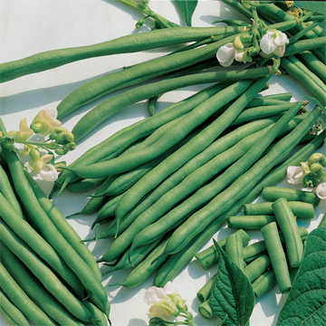
For more information on harvesting the seeds, visit our Caring for Creation website http://uccdg-caring-for-creation.weebly.com/ under the “Education” tab for links to videos that will show you how to harvest your bean seeds.

Calendula - (color variety is Lemon Cream)
Calendulas (Calendula officinalis) add a splash of color to garden beds with their showy golden flowers, which bloom all summer. They grow well within U.S. Department of Agriculture hardiness zones 3 through 10, although their germination requirements differ depending on the local climate. In cooler areas, it is best to start calendula seeds indoors approximately four to six weeks before the last spring frost. In warmer climates, the seeds germinate best when planted outdoors in spring once soil temperatures reach 65 degrees F. Either way, calendula seeds germinate reliably and will reach a mature height of 8 to 24 inches in just a few months.
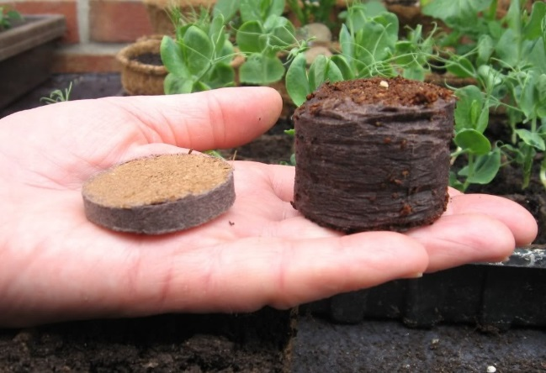
We’ve filled your peat pots, placing two calendula seeds on the surface of the soil in each peat pot and pressing them gently into the soil and covering them with about 1/4-inch-thick layer of soil.
3 We spritzed each peat pot with a water-filled spray bottle until the top 1/2 inch of soil feels moderately moist. We’ve covered the pots with a layer of plastic to create a greenhouse-like environment for the seeds and have poked holes in the plastic top to allow to permit some air for the plants.
When you get home, keep the bowl with the peat pellets in the dark until the seeds germinate (10-14 days). Be sure to check them daily and ensure they pellet are moist but not overly wet. Avoid letting the soil dry out for more than 12 hours.
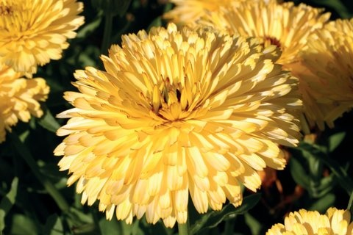
After they begin sprouting - Discard the plastic top and remove the weaker of the two calendula seedlings from each pot if both seeds germinate. Move them to a sunny window (6-8 hrs a day) and let me get to 3” in height. Plant the entire pellet in your garden. They will grow in poor soil, sun or partial shade. Calendula plants will thrive in full sun, fertile soil and cool weather, but will bloom satisfactorily in all conditions except deep shade and extreme heat.

To harvest seeds for next year’s blooms - cut some of the flowers and let them dry out. Then harvest the seeds from the flowers.

For more information on harvesting the seeds, visit our Caring for Creation website http://uccdg-caring-for-creation.weebly.com/
and look under the “Education” tab for links to videos that will show you how to harvest your bean seeds.

